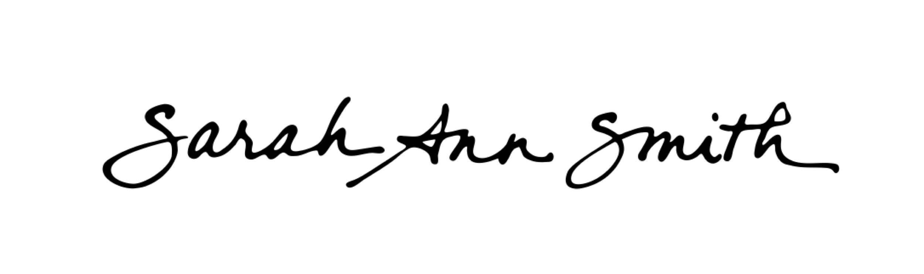
www.SarahAnnSmith.com sarah@sarahannsmith.com
339 Ludwig Road Hope, Maine 04847

This information may be used by the press, guilds and shows. Included are bios of varying lengths

Sarah’s road to art was a rather circuitous and unusual one…..
As a young child, Sarah lived in Spain, Thailand and Argentina. Shortly after her sixth birthday, her family returned to the United States to live. That year a neighbor girl made an apron for Sarah's favorite doll, sparking a fascination with fiber that continues to this day. Before long, Sarah began making clothes for her dolls and trolls, then graduated to clothing for herself.
At the San Domenico School in San Anselmo, California, Sarah learned to love learning, and is grateful for the nurturing environment provided by the Dominican Sisters. It was here that Sarah seriously began to learn how to sew, and first saw someone making a quilt and knew instantly that she wanted to learn how. It was also in high school that her art teacher expressed disappointment that, when Sarah had to choose, she opted for sewing over art classes; thank you Mrs. Hoffman for that vote of confidence!
It took nearly fifteen years until Sarah found her first book on quilting. By that time, she had graduated from Georgetown University's School of Foreign Service; worked as a Legislative Assistant for a U.S. Congressman in Washington, D.C.; earned a Master of Arts in Law and Diplomacy from The Fletcher School of Law and Diplomacy in Medford, Mass.; volunteered in Guinea-Bissau with Operation Crossroads Africa; met her soon-to-be-husband, and became a U.S. Foreign Service Officer (diplomat). Sarah's first tour with the U.S. Foreign Service was in Toronto, Canada, where she took her first drawing classes while living across the street from the Art Gallery of Ontario.
Finally, fate picked up a thimble: while assigned to the U.S. Embassy in La Paz, Bolivia, Sarah came across someone's discarded Keepsake Quilting catalog, which opened up the doors to the quilting world. Sarah hasn't looked back since--at long last, a way to marry her love of sewing with her love of art! Much later, in 2002, another set of doors opened when Sarah joined the artquilt list (www.quiltart.com), which she has called her education in the art and business of art quilting.
After returning to the States in 1991, her first son was born and, in 1997, the Smith family opted out of the rat race. Just as her husband was ready to retire and Sarah resigned from the Foreign Service to raise their family, their second son was born. From 1998 to 2004 they lived on San Juan Island, an island paradise 20 miles off the coast of Washington State. While there, Sarah began her own business doing custom sewing for the home, providing great experience in creating one-of-a-kind patterns for home decorating projects.
A quest for better schooling for the boys led the family to Camden, Maine, in 2004, where Sarah relishes the supportive environment for fiber art and art quilts. In 2011 the family moved to next-door Hope, Maine. Sarah considers herself most fortunate to have two wonderful sons, a husband who believes in her art and be able to do what she loves—sew and make art.

